**Lab 1 Activity 9 - Track Changes and Comments**

**Objective** – Learn how to track changes and add comments in a collaborative document.

1. Turn on "Track Changes" and make edits.
2. Accept or reject changes made by others.
3. Add comments to specific parts of the document.
4. Review comments and resolve or delete them

**____________________________________________________________________________________**

**Solutions:**

**Task 1:**

To open track changes:

* Open your document in Microsoft Word.
* Go to the Review tab at the top of the screen.
* In the Tracking group, click on Track Changes. You’ll see that it is highlighted to indicate it's turned on.
* Now, any edits you make (deletions, insertions, formatting changes) will be tracked and shown in the document.

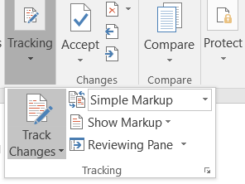

**Task 2:**

* When someone else has made changes to the document (while "Track Changes" is on), you can review and decide whether to keep or remove those changes.
* Go to the Review tab.
* In the Changes group, you'll see options to Accept or Reject changes

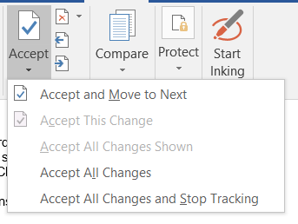

**Task 3:**

* Highlight the text or place your cursor where you want to add a comment.
* Go to the Review tab.
* In the Comments group, click New Comment.
* A comment box will appear in the right margin of the document where you can type your feedback or notes.
* The comment will be linked to the text you highlighted or selected.

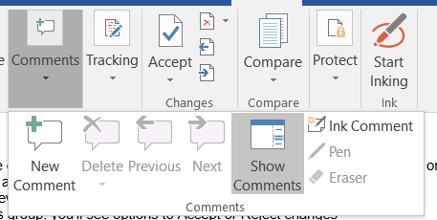

**Task 4:**

* To review comments, simply click on any comment in the right margin. You can reply to comments or make edits based on the feedback.
* To delete a comment, click on the comment to select it.
* Then, in the Review tab, in the Comments group, click Delete.
* You can choose Delete to remove just that comment, or Delete All Comments in Document to remove all comments at once.
* To resolve a comment (mark it as addressed), click on the comment and select Resolve. This will mark the comment as resolved, and it will no longer be active, though it can still be seen in the document if needed.